

AUTOID® Q7-(Cold)-1.4Q4-7.1 SERIES PORTABLE DIGITAL TERMINAL
PRODUCT SPECIFICATION V1.8

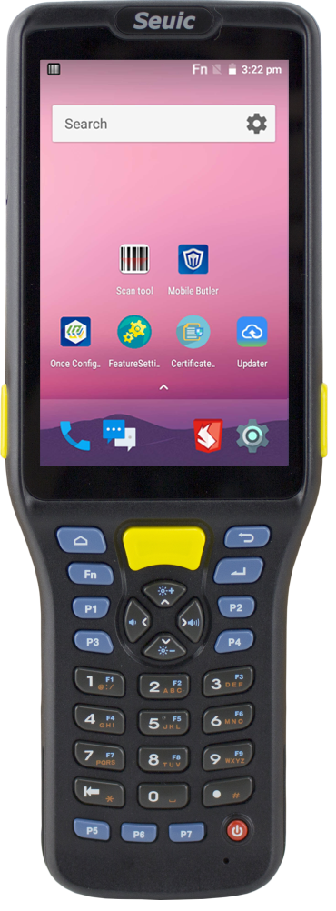

SEUIC Technologies Co., Ltd

- AUTOID® Q7-(Cold)-1.4Q4-7.1 PERFORMANCE CHARACTERISTICS
CPU | Cortex™ Quad core 1.4GHz
Operating System | Android7.1
RAM | 2GB
ROM | 16GB
Expansion Slot | Micro SD Card, 32GB SDHC compatible
Interface/Communication | Support USB2.0 High Speed, support OTG
Keypad | 31keys
Keypad | LED(buttons with backlight)
Display | 4.0 inch size industrial grade low temperature resistant, Capacitive, touchable, dual mode touch-with or without a thick glove / with or without wet hand
Display | 800(H)×480(W) (WVGA)
Power | Detachable 3.7V rechargeable Li-ion battery,  Average capacity 6200mAh  Rated capacity 6000mAh
Power | Built in li-ion backup battery
Power | Standard Micro USB, intelligent identification of PC and special charger; support Charging Cradle
Notification | Sound, Vibrator, LED indicator
Audio | Built-in loudspeaker, built-in microphone
Sensor | Optical sensor, Proximity sensor
Dimension | 203(H)×72(W)×35(T)mm , (width 70mm side keys excluded)
Weight(including standard battery) | WIFI version: 490g (battery and grip pistol included, varies by different configurations)
Operating Temp | -25℃ to +50℃
Storage Temp | -40℃ to + 60℃ (Battery included)  -40℃ to + 70℃ (Battery excluded)
Humidity | 5% to 95% RH non-condensing
Sealing | IP65
Drop Specification | Multiple 4.9 ft./1.5m drops to marble across the operating temperature range
Tumble Specification | 1,000 1.64 ft./0.5 m tumbles (equals to 2,000 drops)
ESD | ±15kV Air discharge,±8kV direct discharge

- AUTOID® Q7-(Cold)-1.4Q4-7.1 DATA CAPTURE OPTIONS
Option 1 | 2D Image Scan Engine (option1)
Sensor Resolution | 1280(H)×800(V)
Rotate | 360°
Pitch Angle | ±60°
Skew Tolerance | ±55°
Laser safety grade | Class II
Image frame rate | 60fps
Scan depth | Code128: 10cm(5mil), 80cm(20mil)
Code support | UPC/EAN, UPC/EAN, Code128, GS1-128, Code 39, Code 32, Code 93, Code11, Matrix 2 of 5, Interleaved 2 of 5, IATA 2 of 5, Industrial2 of 5, Codabar, MSI ,Code11 etc.  PDF417, MicroPDF417, Data Matrix, Maxicode, QR Code, MicroQR, Aztec etc.
Light source system | White light, Red cross-shape laser aiming
Minimum printing contrast | 20%
Option 2 | Camera (option 2)
Maximum Resolution | 2592*1944(taking photo), 1080P 30fps (making video)
Photo Function | Auto-focus
Pixel | 5 mega
- AUTOID® Q7-(Cold)-1.4Q4-7.1 WIRELESS DATA COMMUNICATIONS
Option 1 | WLAN WIFI
Protocol | IEEE 802.11a/b/g/n/ac(2.4G/5G dual-frequency WIFI)
Frequency Range | Depends on different countries (regions), 2.4GHz: 2.412GHz-2.477GHz; 5GHz: 5.17GHz-5.825GHz
Working Channel | CH1~CH14, CH34~CH165
Security | Safe mode: legacy³, WPA, WPA2, 802.1X  Encrypted mode: WEP40/WEP104, TKIP和AES  ID verification: TIS; TTIS(CHAP³, MSCHAP, MSCHAPv2, PAP或MD5³); PEAP(TIS³, MSCHAPv2, GTC); LEAP;FAST(TIS³, MSCHAPv2, GTC)  Others: Support IPv6
Data Rate | 802.11a: 6,9,12,18,24,36,48,54Mbps  802.11b: 1,2,5.5,11Mbps  802.11g: 6,9,12,18,24,36,48,54Mbps  802.11n: 6.5,13,19.5,26,39,52,58.5,65Mbps(20MHz,Long GI,800ns)  802.11n:7.2,14.4,21.7,28.9,43.3,57.8,65,72.2Mbps(20MHz,short GI,400ns)  802.11n: 6.5,13,19.5,26,39,52,58.5,65Mbps(20MHz,Long GI,800ns)  802.11n:7.2,14.4,21.7,28.9,43.3,57.8,65,72.2Mbps(20MHz,short GI,400ns)  802.11n:13.5,27,40.5,54,81,108,121.5,135Mbps(40MHz,Long GI,800ns)  802.11n:15,30,45,60,90,120,135,150Mbps(40MHz,short GI,400ns)  802.11ac:6.5,13,19.5,26,39,52,58.5,65,78Mbps(20Mhz,Long GI,800ns  802.11ac:7.2,14.4,21.7,28.9,43.3,57.8,65,72.2,86.7(20MHz,short GI,400ns)  802.11ac:13.5,27,40.5,5481,108,121.5,135,162,180Mbps(40Mhz,Long GI,800ns  802.11ac:15,30,45,60,90,120,135,150,180,200Mbps(40MHz,short GI,400ns)  802.11ac:29.3,58.5,87.8,117,175.5,234,263.3,292.5,351,390Mbps(80Mhz,Long GI,800ns  802.11ac:32.5,65,97.5,130,195,260,292.5,325,390,433.3Mbps(80MHz,short GI,400ns)
Antenna | Built-in antenna

- AUTOID® Q7-(Cold)-1.4Q4-7.1 THE THIRD PARTY APPLICATION DEVELOPMENT SUPPORT

System Software | Android 7.1
System programming environment | Android Studio

- AUTOID® Q7-(Cold)-1.4Q4-7.1 PERIPHERALS AND ACCESSORIES

Standard Accessories | Universal Adapter×1, USB Cable×1, Hand Belt×1, battery×1, Silicon protection cover ×1
Optional Accessories | Four Slot Battery Charger, Single Slot Charging Dock include battery (support Ethernet), Single Slot Charging Dock include battery, USB cable with end flap clip, Touch pen, Hand Tether, Five-slot charging dock, Five-slot charging dock(support Ethernet)

